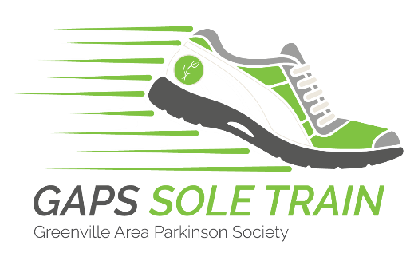

Dear _________________,

I am participating in GAPS Sole Train beginning March 1, 2022. I would like to invite you to be a part of my Sole Train Passenger Car, [Car Name] _____________________!

Each Passenger Car consists of family, friends, and coworkers who “walk their soles off” and raise money for the Greenville Area Parkinson Society between now and the end of the campaign on April 23, 2022.

From now until April 23rd, I also invite you to participate in the Trek For Tokens challenge. The challenge works in two ways: Walking and Donating!

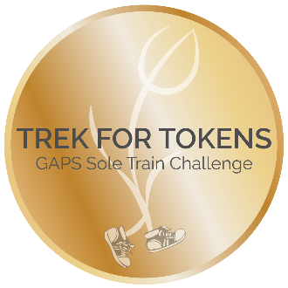
First, start moving! and track the number of steps or miles you walk or run between now and April 23rd (it takes about 2,000 steps to walk 1 mile or 10,000 steps to walk 5 miles). For every 10 miles you walk, our Sole Train earns a token! These "tokens" will be tallied up and contributed to our Car’s overall score at the GAPS Member Celebration and Sole Train Awards! The Train with the most miles will win the Total Tokens Award. Please let me know the miles you are walking!

Second, give online donations to our Passenger Car using the DONATE button on the GAPS website. Or you may mail a check to the Greenville Area Parkinson Society at the address below. Please write “Sole Train 2022 - Car ______” in the memo line.
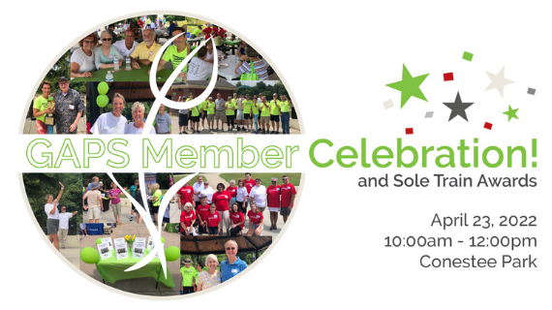
Then, on April 23rd at 10:00am there will be a Member Celebration and Sole Train Awards event at Conestee Park. During this event, Passenger Car members will have the opportunity to earn extra tokens by making day-of donations. The Sole Train Passenger Car that raises the most money will receive an award at the end of the event as Sole Train champion!

Finally, please share this letter with your friends and family and ask them to donate and trek for tokens for “Car _____________________.”

GAPS is a 100% locally founded and funded organization. All money raised by Sole Train Cars stays in our community to support those affected by PD.

Thanks for your support!
Sincerely,

Please visit gapsonline.org to donate, find more information on the Greenville Area Parkinson Society, and see details about the event. Sole Train information is under the Events tab.

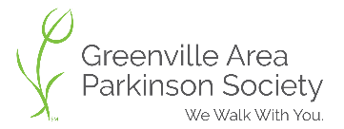
Greenville Area Parkinson Society, P.O. Box 6505, Greenville, SC 29606

